1.public class Main

{

public static void main(String[] args) {

int n = 4;

//Loop to iterate over each row

for (int i =1; i<=n;i++) {

//Loop to iterate over each column of the ith row

for (int j = 1; j<=n; j++) {

System.out.print(i + " ");

}

System.out.println();

}

}

}

OUTPUT:

1 1 1 1

2 2 2 2

3 3 3 3

4 4 4 4

**2. package** pattern;

**public** **class** Sample {

**public** **static** **void** main(String[] args) {

// **TODO** Auto-generated method stub

**int** n=10;

**for**(**int** i=0;i<n;i++)

{

**for**(**int** j=0;j<n;j++)

{

**if**( i==0 || i==n-1 || j==(n-1)/2)

{

System.***out***.print("*");

}

**else**{

System.***out***.print(" ");

}

}

System.***out***.print("\t");

**for**(**int** j=0;j<n;j++)

{

**if**(j==0 || i==j || j==n-1)

{

System.***out***.print("*");

}

**else**{

System.***out***.print(" ");

}

}

System.***out***.print("\t");

**for**(**int** j=0;j<n;j++)

{

**if**( i==0 || j==0 || i==(n-1)/2 || i==n-1)

{

System.***out***.print("*");

}

**else**{

System.***out***.print(" ");

}

}

System.***out***.print("\t");

**for**(**int** j=0;j<n;j++)

{

**if** (j==0 && i<n-1 || i==n-1 && j>0 && j<n-1 || j==n-1 && i<n-1)

{

System.***out***.print("*");

}

**else**{

System.***out***.print(" ");

}

}

System.***out***.print("\t");

**for**(**int** j=0;j<n;j++)

{

**if**((j==0||i==0 && j<(n-1)/2)|| (i==(n-1)/2 && j<(n-1)/2)|| (j==(n-1)/2&&i!=0&&i!=(n-1)/2))

{

System.***out***.print("*");

}

**else**{

System.***out***.print(" ");

}

}

**for**(**int** j=0;j<n;j++)

{

**if**(j==0 && i>0 && i<n-1 || j==n-1 && i>0 && i<n-1 || i==0 && j>0 && j<n-1 || i==n-1 && j>0 && j<n-1)

{

System.***out***.print("*");

}

**else**{

System.***out***.print(" ");

}

}

System.***out***.print("\t");

**for**(**int** j=0;j<n;j++)

{

**if**(j==0 || i==j || j==n-1)

{

System.***out***.print("*");

}

**else**{

System.***out***.print(" ");

}

}

System.***out***.println();

}

}

}

OUTPUT:

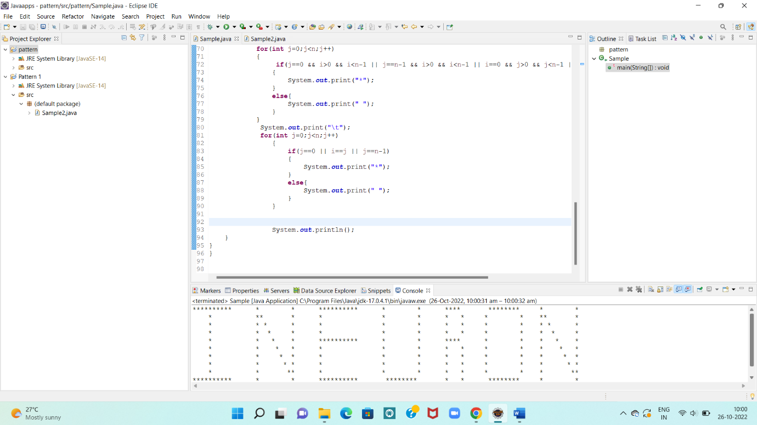

3.

**public** **class** Sample2 {

**public** **static** **void** main(String[] args) {

// **TODO** Auto-generated method stub

**int** n=14;

**for**(**int** i=0;i<n;i++)

{

**for**(**int** j=0;j<n;j++)

{

**if**(i==0 || i==n-1 || i-j>=(n-1)/2 || i+j<=(n-1)/2)

{

System.***out***.print("*");

}

**else**{

System.***out***.print(" ");

}

}

System.***out***.println();

}

}

}

OUTPUT:

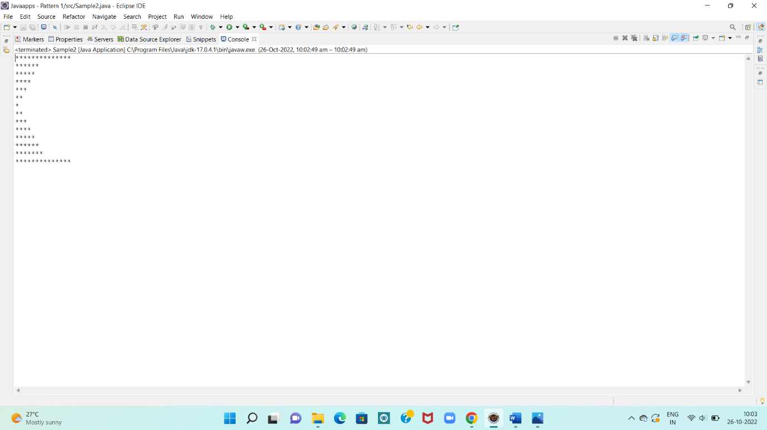

4.

**package** pattern2;

**public** **class** Sample3 {

**public** **static** **void** main(String[] args) {

// **TODO** Auto-generated method stub

**int** n=14;

**for**(**int** i=0;i<n;i++)

{

**for**(**int** j=0;j<n;j++)

{

**if**(i-j>=(n-1)/2 || i+j>=n-1 + (n-1)/2)

{

System.***out***.print("*");

}

**else**{

System.***out***.print(" ");

}

}

System.***out***.println();

}

}

}

OUTPUT:

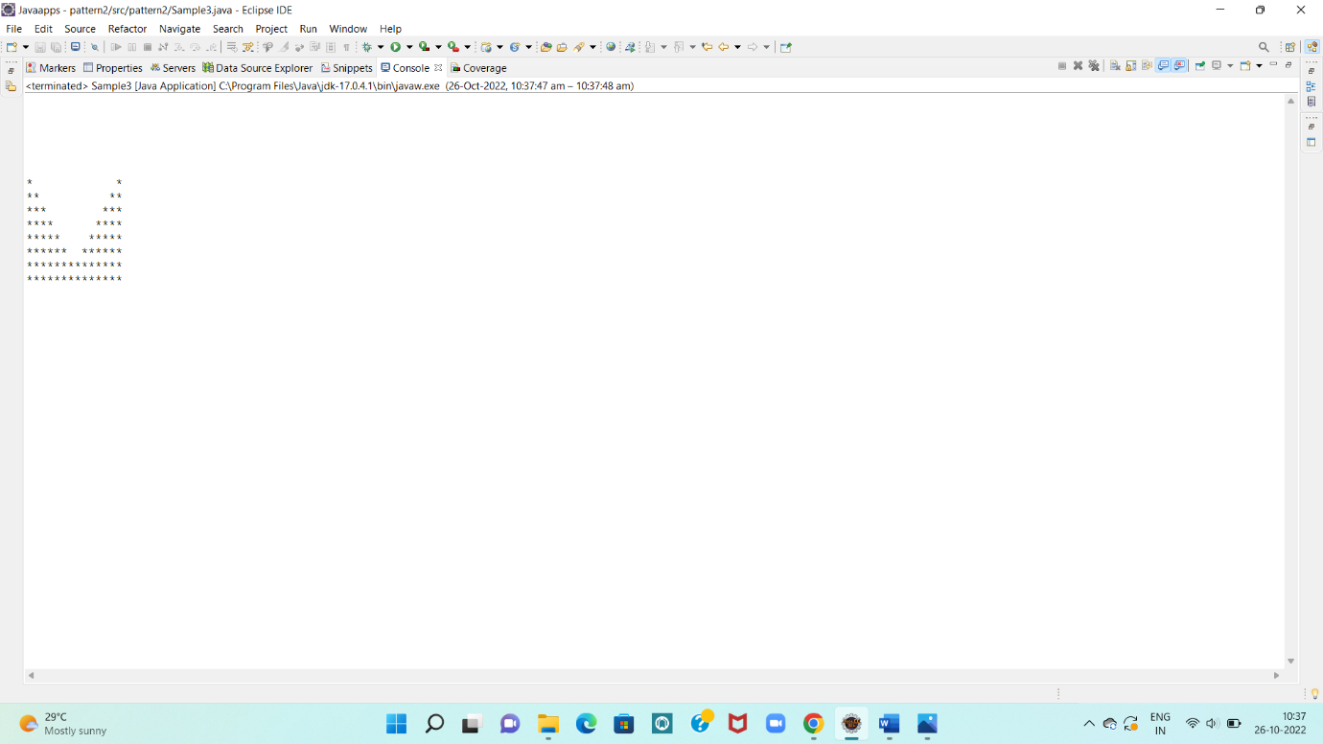

5.

**public** **class** Sample5 {

**public** **static** **void** main(String[] args) {

// **TODO** Auto-generated method stub

**int** n=14;

**for**(**int** i=0;i<n;i++)

{

**for**(**int** j=0;j<n;j++)

{

**if**(i==0||i==n-1||j==0||j==n-1|| i+j<=(n-1)/2||j-i>=(n-1)/2 )

{

System.***out***.print("*");

}

**else**{

System.***out***.print(" ");

}

}

System.***out***.println();

}

}

}

OUTPUT:

